

**Al Hussein Technical University**

**Upskilling Program-C#**

Project Title

**Portfolio**

By

**Ayat Abd Al-Majid Alababneh**

Supervised by

**Khalid Oweis**

Contents

Introduction 3

Overview 3

The project includes 3

This system consists of two users 4

Requirements for User 4

Requirments for Admin 6

Use Case Diagram 7

Class Diagram 8

Source code for The Repositories 10

Websites Screens 16

Concluision 28

**Introduction**:

Portfolios are not just for certain fields or industries anymore. The importance of having a professional online presence is more important than ever, and portfolio will certainly increase your visibility and presence. Creating a portfolio website is if the first step towards getting a potential employer’s attention and scoring a new job. However, in order to achieve that, you first need to make sure that you know how to design portfolio that stands out.

If you are not sure how to make an outstanding portfolio website, you have come to the right place.

**Overview:**

When you think about how to create a portfolio, you should always keep in mind that your portfolio has to be easy to navigate. Creating categories and dividing your work into segments makes it much easier for a person browsing through a portfolio website to had better understand your portfolio and the most important aspects of your work .So, you can easily use the website to create a portfolio for you with this beautiful design

**The project includes:**

The site has a beautiful view .It includes many pages and elements. There are more than one action in home page. Like, login as an exist user, register as a new user at the web site. An about section which includes an overview about what the site does, How to use section, which shows the steps for creating a user's portfolio , Portfolio section displays one of the forms created on the site and contact section that contains a form to send any comment on the site.

Once you pass the authentication screen, the site will re-direct you to the same home page with another section added for the authorized user called view portfolio that will take you to your E-Portfolio to begin the process of adding your information, once you done save your new info has to get your portfolio URL and share it around.

**This system consists of two users:**

Admin and User.

**Requirements for User:**

1- Upon entering the site, the main page of the site will appear which contains information about the site and some terms that indicate the definition of the personal portfolio.

2- The user must log in to the website to be able to create his own personal portfolio.

3- If the user does not have an account on the web site, they must create an account to access the web site services.

4- When creating a new account for the first time, the user must create a portfolio and fill in the information required of him.

5- The user will not be transferred to the other page unless all the information requested from him has been filled out, which are some personal information, information about his studies, information about the skills he possesses, information about the projects he has undertaken, and finally information to contact him.

6- When a user has filled out all his information, clicks the send button, an email are sent to him with a link to his personal wallet.

7- When the website sends an email to a user with a link to their personal wallet, the user is take to their portfolio view page.

8- On the Portfolio View page, the user can choose between either returning to the main page, adjusting his / her own portfolio.

9- If the user chooses the option to modify his wallet, he is transfer to the modification page for a wallet, and the user modifies the information he wants to modify.

10- Before pressing the submit button, the user must make sure that all fields are full of information, otherwise it will not move him to the next page.

11- When you click on the Submit button, the user will moved to the Portfolio display page, and all the changes made by the user will displayed.

12- If the user chooses to press the home button, he will take to the main page of the site where there is general information about the site.

13-If the user previously had an account on this site and created his own wallet, all he had to do was log in to the site using his email and password.

14- When logging in to the site, the user will take directly to the display page of his portfolio and displaying all his information that was previously fill in.

15- When the user finishes using the site, he logs out of his account.

16- When the user logs out from the site, he is move to the site's home page.

17- The user must know that he must fill out all the information required of him on the portfolio creation page, otherwise the portfolio would not created for him.

This information includes his name in three sections, his personal photo, phone number, date of birth, address, email, some links to social media sites such as Twitter and LinkedIn the Facebook, Job title, about you, personal vision, and résumé. All this is contained in the personal information that he must fill in.

As for the information related to his studies, he must fill in the name of the university in which he studied in addition to the academic degree and specialization he studied in this university.

For information related to the projects, he has undertaken, including a picture of this project in addition to a copy of this project in the form of a PDF file, and the name of the project. A small description of the project, and finally information about the skills that the user possesses, whether they are technical skills or soft skills.

**Requirements for Admin:**

1- As for the admin, the first thing he must do when entering the site is to log in using his email and password.

2- When the admin logs into his account, be directly moves it to the private admin home page.

3-The admin home page contains a table containing all users who use this site, table containing all universities, table containing all skills, table containing all degree.

4- When the admin press the delete university button in the table, or the delete skill button, it will deleted directly.

5- When the official clicks the “add university or skill” button, he moves it to a page where the admin adds the university or skill he wants.

6- When the admin finished all his work in the system, he logs out of the site to preserve his private data and is transfer directly to the main page of the site.

Use Case Diagram:

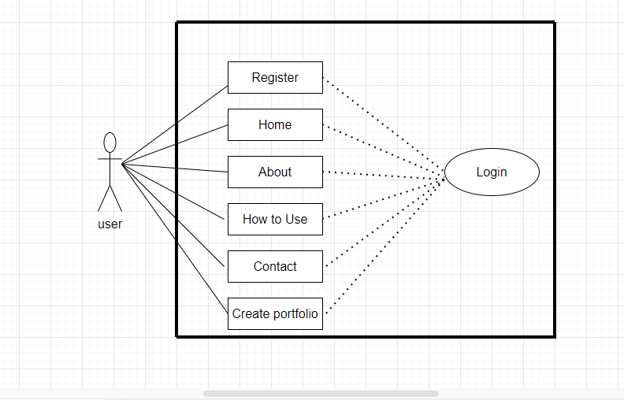

Class Diagram

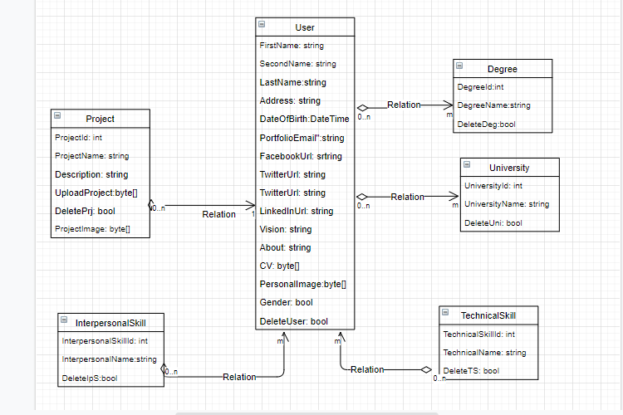

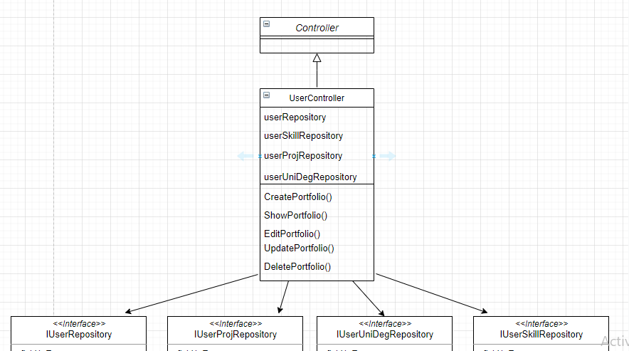

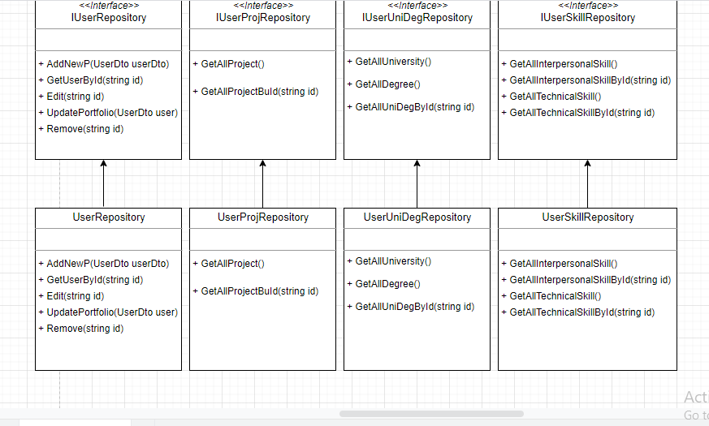

**Source code for the Repositories:**

1-User Repository

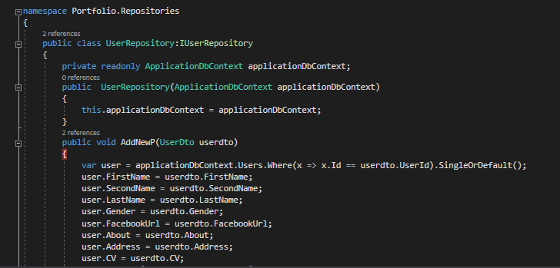

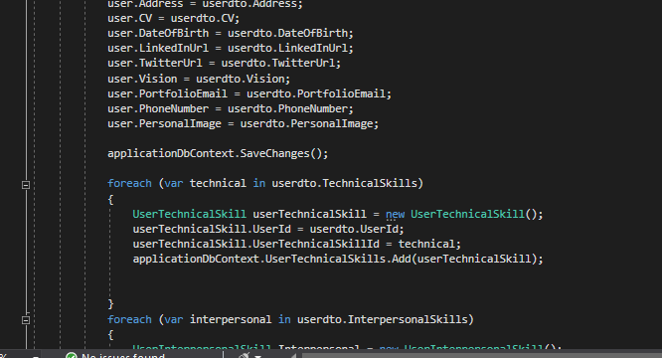

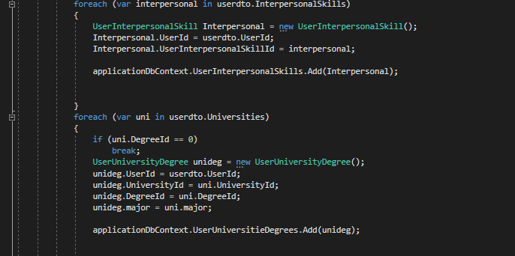

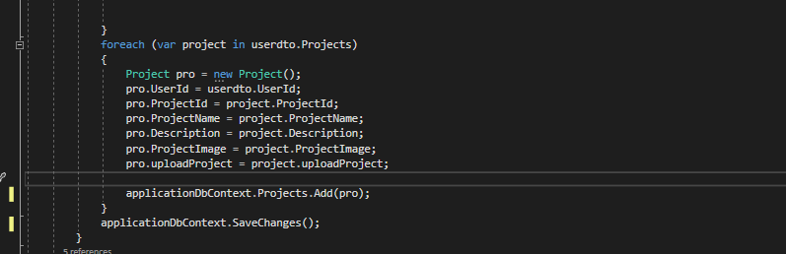

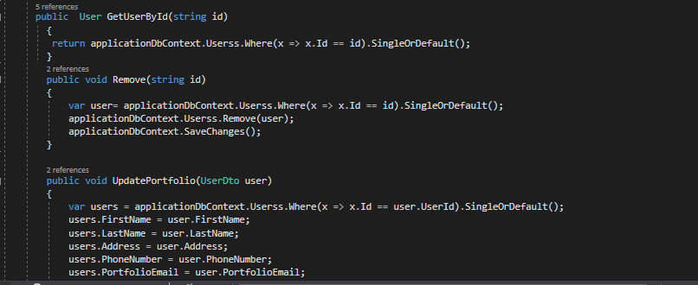

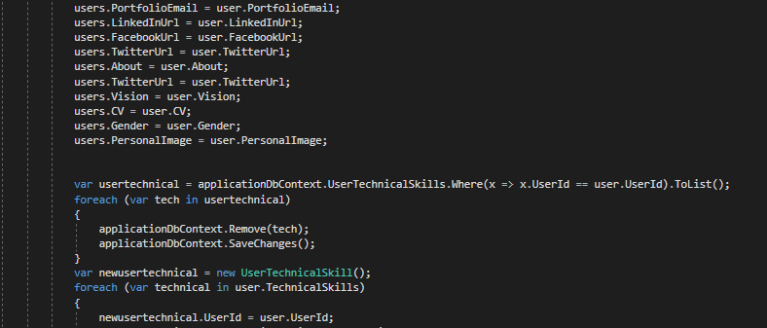

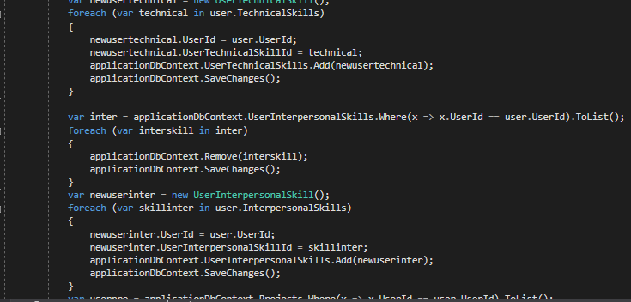

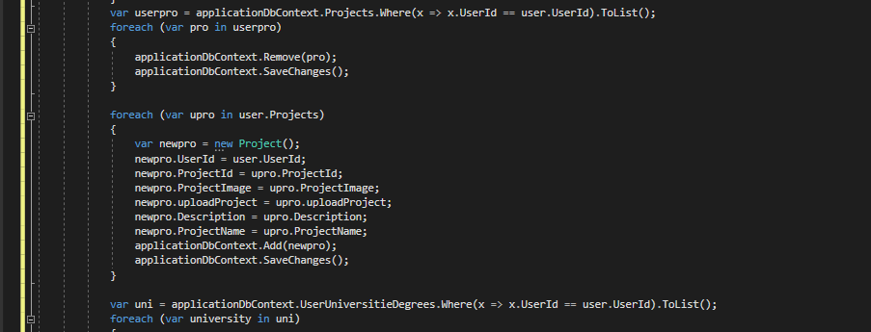

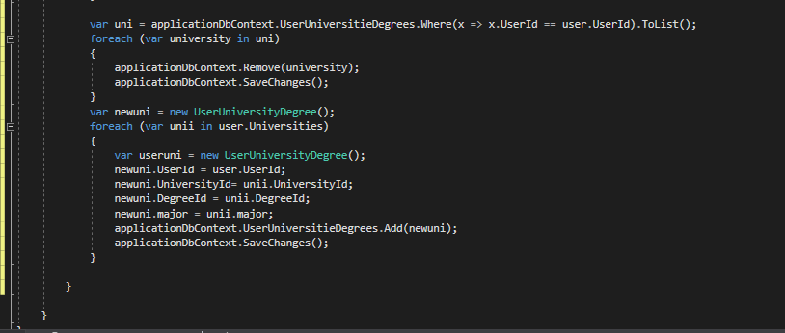

2-User University Degree Repository

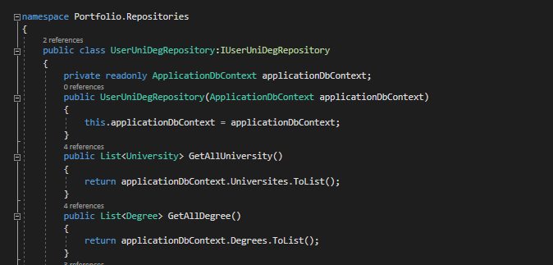

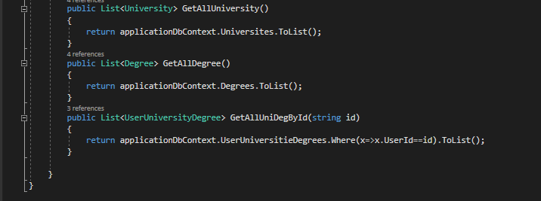

3-User Project Repository

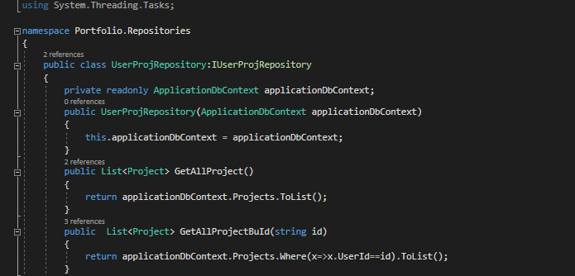

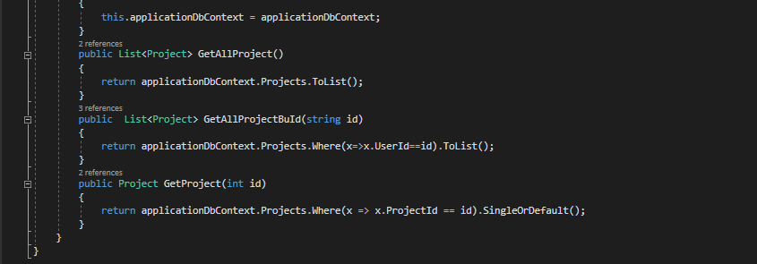

4-User Skill Repository

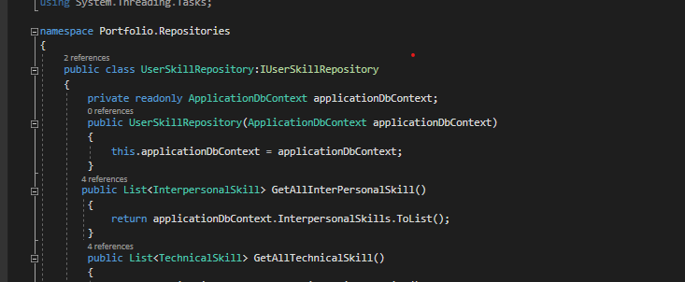

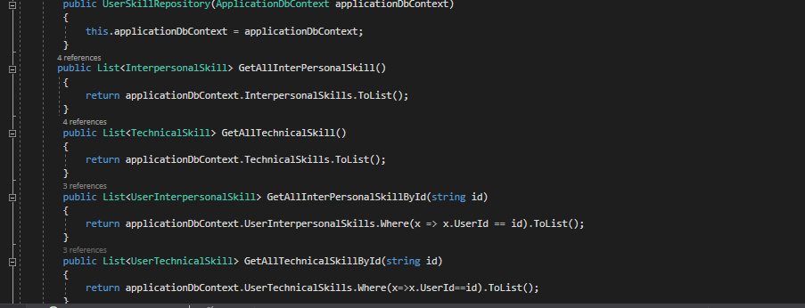

**Website Screens:**

1-Home Screen

This is the home page of the website; it contains some information and the purpose of this website.



2-About Screen

This is the second part of the home page, and this section contains some information related to the site and a simple definition of Portfolio.

*GET STARTED button:

Clicking this button takes you to the page where you can create your personal portfolio.

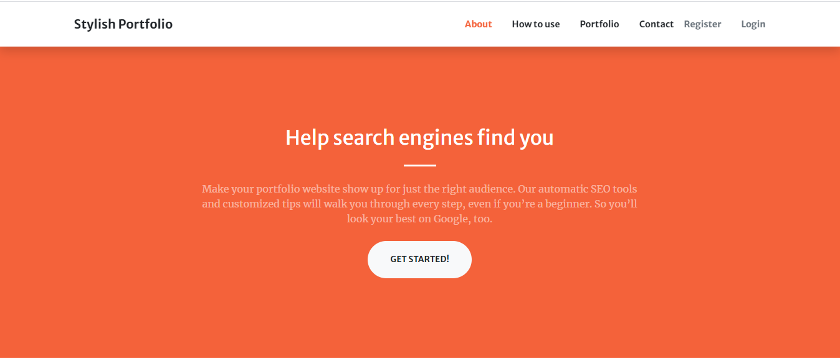

3-How to Use Screen

This is the third part of the home page, and this section contains how to create personal portfolio.

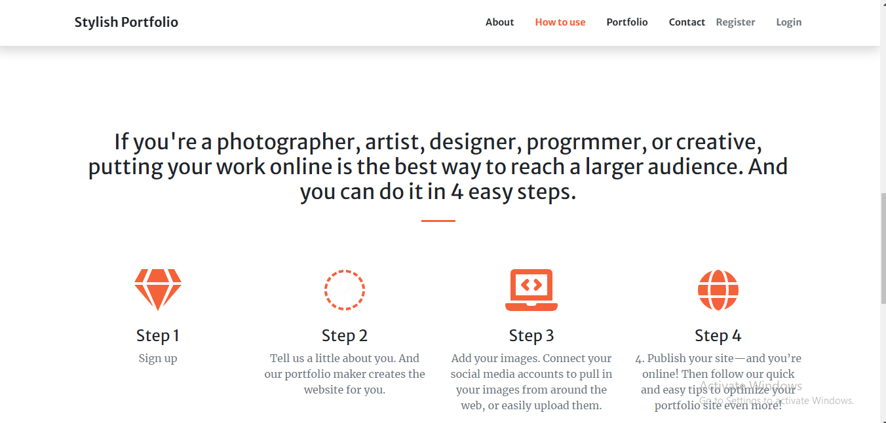

4-Portfolio:

This is the fourth part of the homepage. This section contains a sample portfolio.

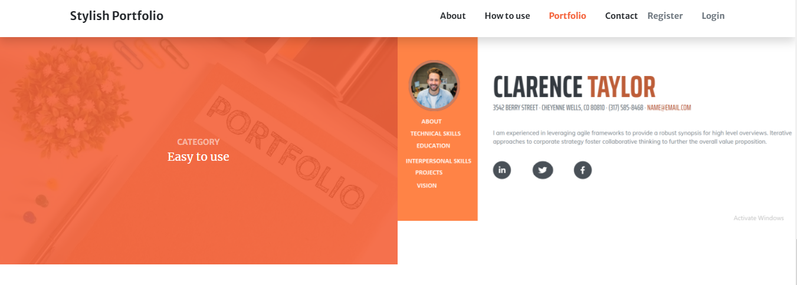

5-Contact and Footer:

This is the last part of the homepage. This section contains some information for the admin to communicate.

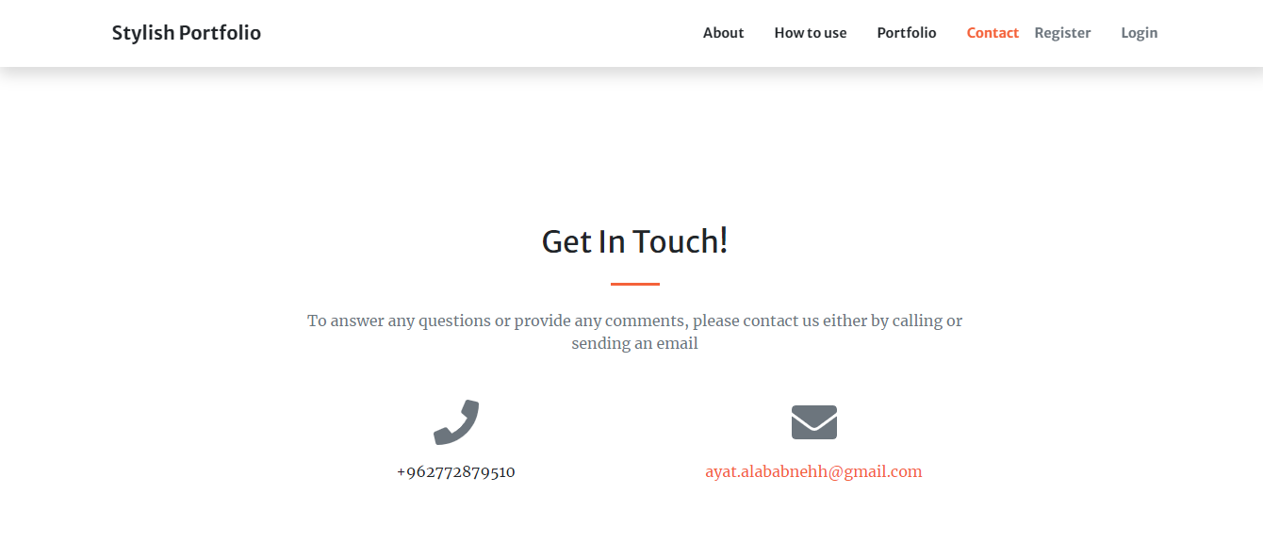

6-Home Screen for user:

This is the user's home page, the difference between it and the web site home page is that it contains the action that the user can do.

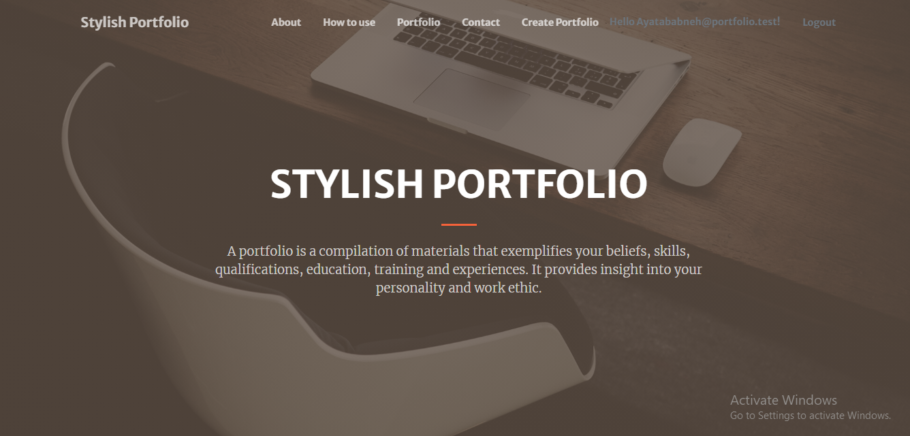

7- Create screen and fill information:

This is the portfolio creation page, the user fills in all the required information, and this information is his personal information in addition to information related to education and some projects he has undertaken in addition to the skills that he possesses.

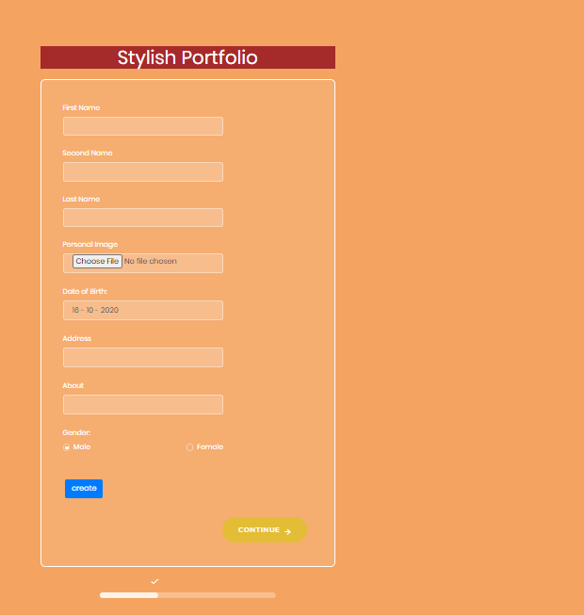

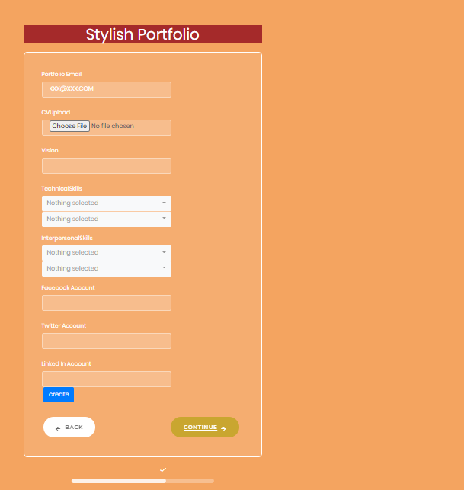

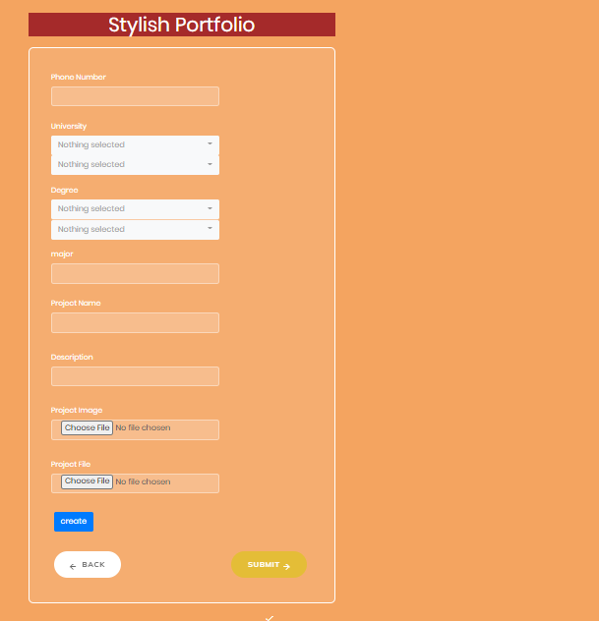

8- My Portfolio Screen:

This part is the final design of the personal portfolio. That contains the information entered by the user.

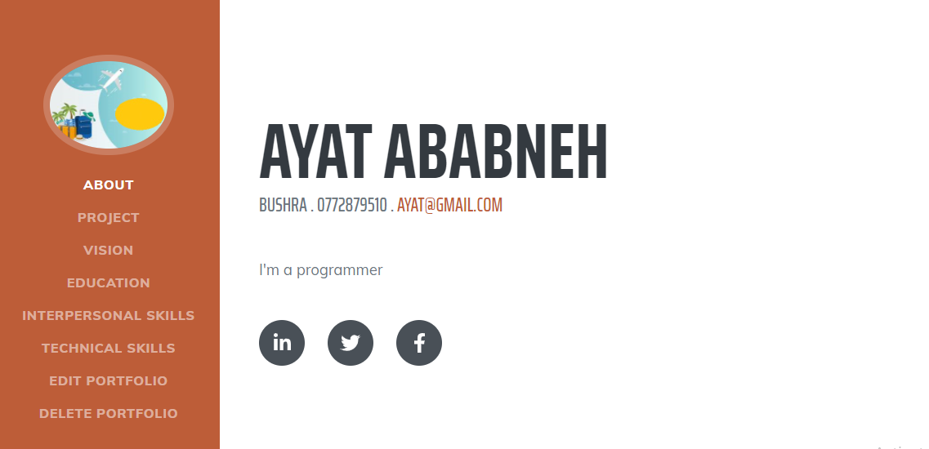

9- Login Page:

This is the login page to the site. That contains the password e-mail for the user to be able to log in his profile.

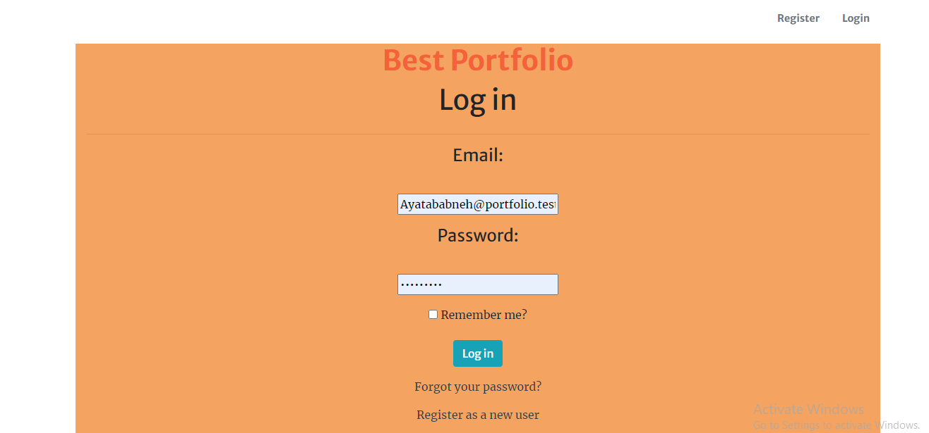

10-Sign up Page:

This is the registration page for this site. The user must enter his e-mail and password and retype the password again to verify it.

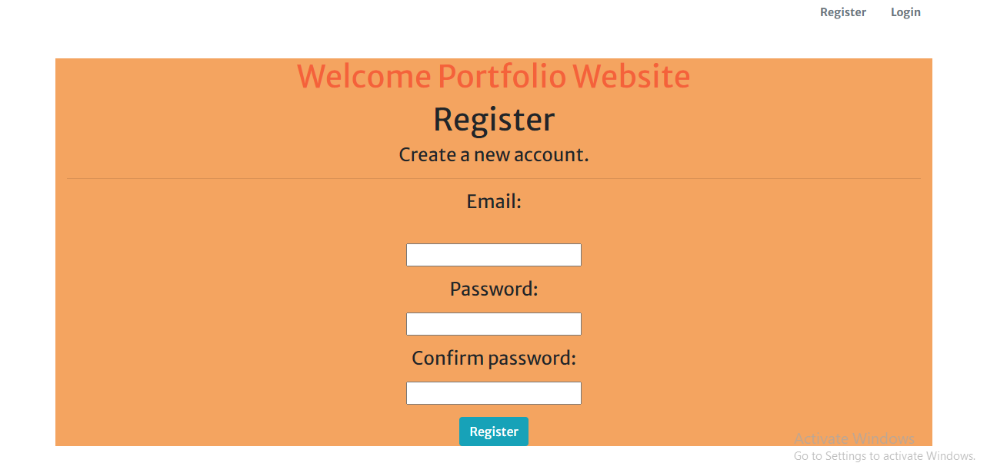

11- Users for admin:

This is the admin home page. That displays all users who use the site and have accounts on this website.



12-University for admin:

On this page, all the universities in the database are display and display for the user to choose from it. This page enables the admin to delete, add or modify a university only by pressing the button that indicates the operation he wants to perform.

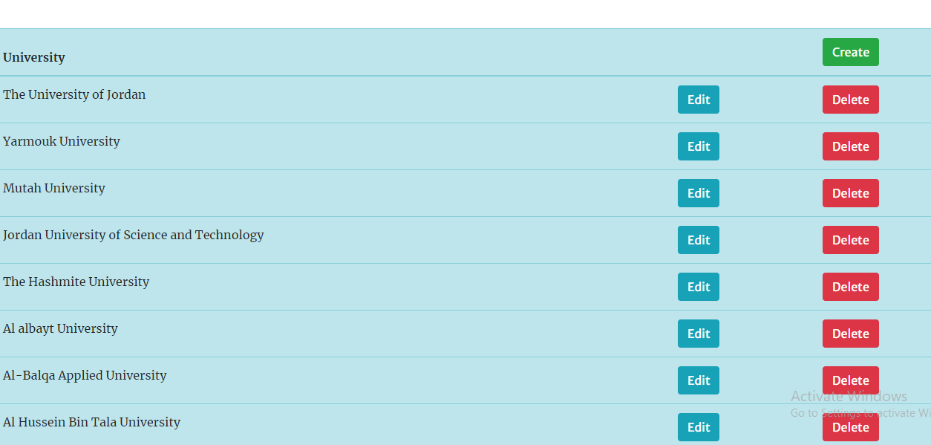

13- Technical skills for admin:

On this page, all the Technical skill in the database are display and display for the user to choose from it. This page enables the admin to delete, add or modify a Technical skill only by pressing the button that indicates the operation he wants to perform.

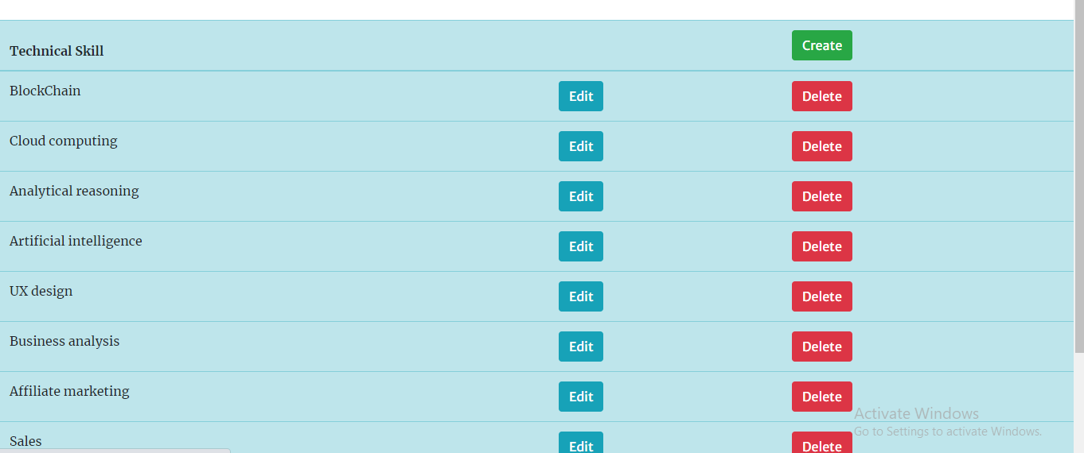

14- Interpersonal skills for admin:

On this page, all the Technical skill in the Data Base are display and display for the user to choose from it. This page enables the admin to delete, add or modify a Technical skill only by pressing the button that indicates the operation he wants to perform.

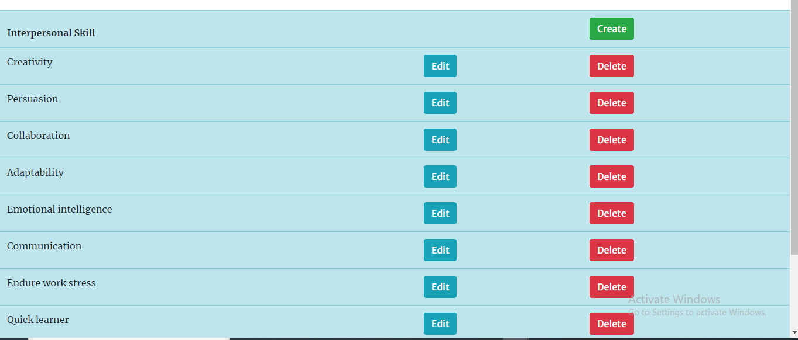

15- Edit screen for admin:

On this page, only the administrator can edit any site-related information in the database.

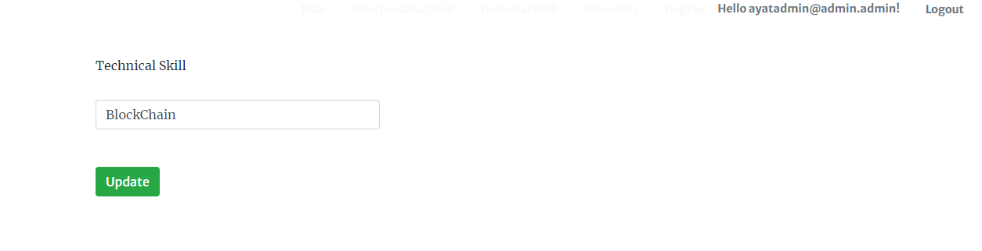

16- Create screen for admin:

On this page, the admin can add new information about website to the database.

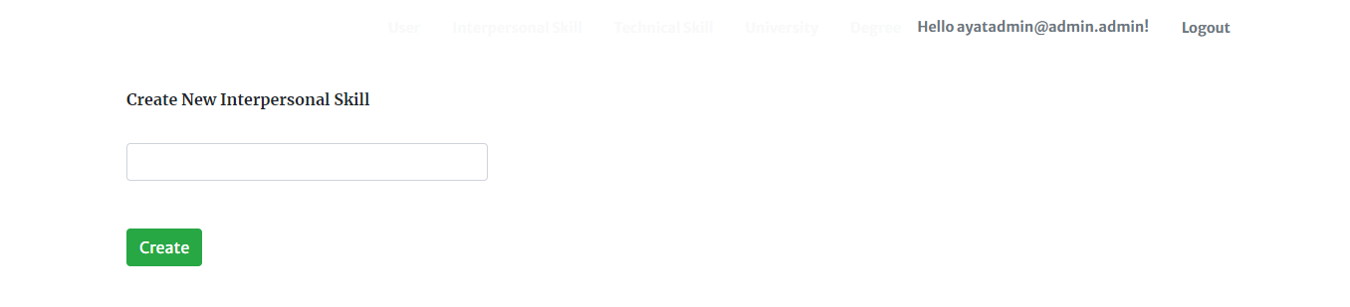

**Conclusion**

I seek to add everything new to the site to become more easily to help many users. The site is an eye-catching one just like any other social media website. It consists of basic elements and sections. There is a login section to register in the website. It also contains “about” which provides a description of the website. The website also enables you to write any comment by using the contact section. To log on the website, first you need to pass the authentication part where you can register your username and password, which directs you portfolio homepage that contains another section called view portfolio, once you click on this section you will direct to E- Portfolio where you begin adding your information. As soon as you finish, you get immediately the URL of your portfolio and share it with other people.